Shadow Tunnels

Joel Morsillo (6252) & Norris Wu (6654)

Game Info

Name: Shadow Tunnels

Genre: Horror/adventure

Target audience: 14 – old

Premise/Basic Idea:

The main character has become lost in the famous Shadow Tunnels who no one has ever returned from. He must find his way out of the tunnels while avoiding the unspeakable horrors to live to see the light of day again. The main mechanics are closing doors and hiding in patches of light to escape from the monsters and button puzzles. The game only uses arrow keys and space, with the space for interact.

Goal: Escape the tunnels without dying.

Gameplay Elements

The game is based in a series of tunnel mazes. Each stage has a different monster who acts differently from the last, some with special abilities and speed. The player can escape by hiding in the rare spots of light or by closing grates to escape the monster. Each stage has an exit but the player needs to find and press the switches in a certain order to cause the grate to open. Spacebar is the only button other than arrow keys for movement and it is used to interact with switches and objects.

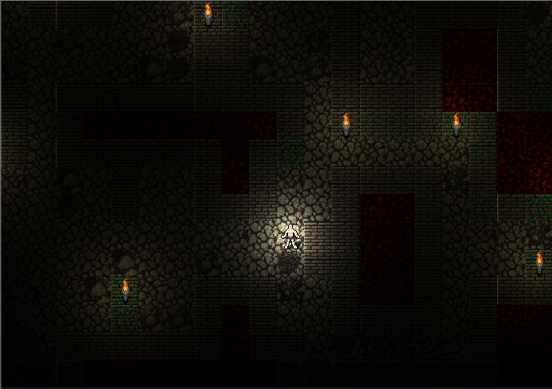

Darker version of this is a good example.